

MCA Semester – IV

Project – Final Report

|  |  |
| --- | --- |
| **Name:** | Fraron Balsara  Shreya Agarwal  Rahul Sharma  Girija Deshpande  Mitali Giri |
| **Project** | E-Mart (E-Commerce Full Stack Web Application) |
| **Group** | FSD Group 11 |
| **Date of Submission** | 18/08/2023 |



**A study on “E-Mart (E-Commerce Full Stack Web Application)”**

*A Project submitted to Jain Online (Deemed-to-be University)*

*In partial* ***fulfilment*** *of the requirements for the award of:*

**Master of Computer Application**

*Submitted by:*

|  |  |
| --- | --- |
| Fraron Balsara | 211VMTR00242 |
| Shreya Agarwal | 211VMTR01338 |
| Rahul Sharma | 211VMTR01079 |
| Girija Deshpande | 211VMTR00366 |
| Mithali Giri | 211VMTR00470 |

*Under the guidance of:*

Miss/Mrs. Nidhi Gupta

Jain Online (Deemed-to-be University)

Bangalore

**2021-23**

# DECLARATION

We, the below mentioned students, hereby declare that the Project Report titled   
*“(E-Mart E-Commerce Full Stack Web application)”* has been prepared by us under the guidance of the *Miss/Mrs. Nidhi Gupta.* We declare that this Project work is towards the partial fulfilment of the University Regulations for the award of the degree of Master of Computer Application by Jain University, Bengaluru. We have undertaken a project for a period of one semester. We further declare that this Project is based on the original study undertaken by us and has not been submitted for the award of any degree/diploma from any other University / Institution.

Place: Mumbai Fraron Balsara (211VMTR00242)

Date: 18/08/2023 Shreya Agarwal (211VMTR01338)

Rahul Sharma (211VMTR01079)

Girija Deshpande (211VMTR00366)

Mitali Giri (211VMTR00470)

# ACKNOWLEDGEMENT

Foremost, I would like to express my sincere gratitude to my advisor Miss/Mrs. Nidhi Gupta for the continuous support during project development, for her patience, motivation, enthusiasm and immense knowledge. Her guidance helped me throughout the process of development of this project. I cannot imagine having a better mentor for my project. Besides my advisor, I would like to thank all the previous professors who taught us HTML, CSS, JavaScript, React and Spring Boot. They taught me the fundamentals really well which helped me throughout the development of this project. Having completed their classes and course made this project simpler for me. Finally, I’d like to thank my fellow classmates for the stimulating discussions, constant encouragement and for all the fun and support throughout the project development process.

# EXECUTIVE SUMMARY

E-Mart E-Commerce Web Application was created with the primary goal of helping local businesses and vendors sell their products online and reach a broader customer base. The goal was also to provide customers with an interactive and creative web application to enhance their online shopping experience.

This web application was created using a 3-tier architecture, where the frontend was designed using React.js, backend was created using Spring Boot and MySQL was used for the database.

Seller role was created and given permissions to add products, view products and manage their own products by taking actions like modifying and deleting their products from the system.

Customer role was created to allow users to view all the products in the system added by the various sellers. Customers can add or remove these products from their cart. They can view the products in their cart from the cart page and modify quantity or delete the items in the cart based on their preference. Customers can choose to purchase the products in their cart by going through checkout and confirming the delivery address and selecting the payment mode as cash on delivery or online. Razorpay was integrated to manage online payments. Once checkout is completed the order is placed in the system. Customers can view all the orders they have placed in the system from the my orders page.

Unregistered users are also able to access the web application and view all the products listed in the system by the various sellers. However, they cannot add products to cart or perform any other actions without signing up/logging in.

Admin role was created to help manage and maintain the E-Mart Web Application. Admins can login and view all customers and sellers in the system, they can also choose to remove these users from the system if necessary. Admins can also view all the orders placed in the system and mark them as dispatched or delivered.

In this manner an interactive and creative E-Commerce Web Application was created and named E-Mart for users to utilize as per their need.

# TABLE OF CONTENTS

|  |  |
| --- | --- |
| **Title** | **Page Nos.** |
| 1. Introduction | 7 |
| 1. System Architecture | 8 |
| 1. Technologies Used | 11 |
| 1. Front-end Development | 12 |
| 1. Back-end Development | 23 |
| 1. Database Design | 25 |
| 1. Authentication and Security | 28 |
| 1. Project Management | 29 |
| 1. Results and Evaluation | 30 |
| 1. Conclusion | 31 |

# Introduction

* In the post covid world E-commerce has become a major attraction for customers as they can shop from the convenience of their homes without having to step out. This presents ordinary local businesses/vendors with a great challenge as they have to transition towards online shopping. The purpose of this capstone project is to bridge that gap and enable local businesses/vendors to present their products on our E-Mart Web Application where customers across geographies can view and place orders to purchase their products.
* E-Mart Web Application is built on the B2C (Business to Consumer) model allowing businesses to directly sell products to consumers.
* Our objective for the sellers/vendors includes providing them with a stable and intuitive platform to display their products for numerous users across geographies at a nominal cost. We want to assist local businesses/vendors to further their customer reach and grow their businesses by helping them increase their sales.
* Our objective for the customers includes providing customers various options to choose from so that they can compare and buy products that suit their needs at the lowest available cost; improving customer experience and customer satisfaction.
* In the fast-paced world of E-Commerce, Full Stack Development plays an important role ensuring local businesses can offer their customers a seamless and efficient online shopping experience. It also allows for effective database management, integration with third-party services, customization and scalability, time and cost efficiency, flexibility and improved collaboration between businesses and customers.
* E-Mart Web Application is built using several of the latest technologies stacks like React.js for frontend development, Spring Boot for backend microservices architecture and API calls, Razorpay API for online payment integration and MySQL as the database.

# System Architecture

* E-Mart Web Application has a 3-tier architecture compromising of the   
  UI (User Interface) layer or frontend, application layer or backend and the database layer.
* The UI layer or the frontend is developed using React.js along with Bootstrap to create responsive web pages that can be accessed from any device to view the application and display the data on the screen. The UI layer interacts with the application layer (backend) by making API calls using HTTP methods. The UI layer does not interact with the database directly.
* The application layer or backend is created using Spring Boot and microservices architecture. It interacts with the UI layer and listens for API calls made by the UI layer using HTTP methods. The application layer then performs CRUD (Create, Read, Update, Delete) operations on the data in the database on behalf of the UI layer. The application layer acts as an intermediary between the UI layer and the database layer.
* MySQL relational database management system is used in the database layer. The database only interacts with the application layer and is isolated from the UI layer for enhanced security and to maintain data integrity. The database will allow the application layer to perform CRUD operations on it, on behalf of the UI layer. However, it does not interact with the UI layer directly.

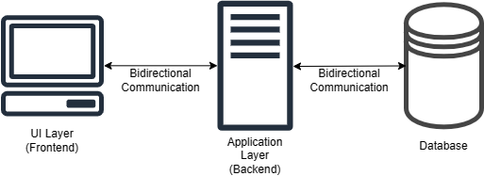

Fig 2.1: 3-Tier Architecture

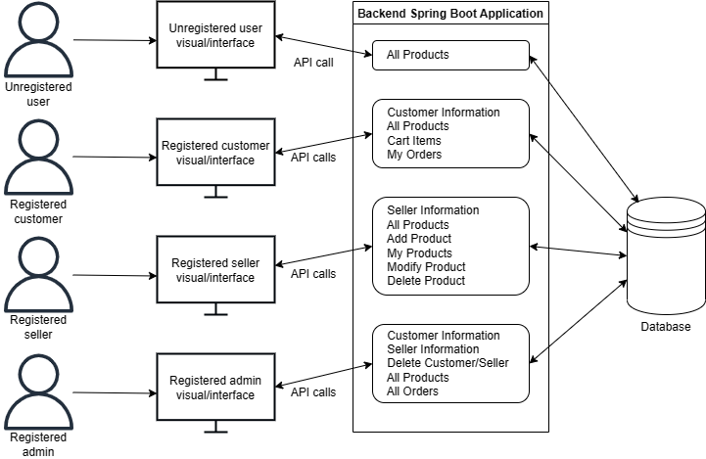

Fig 2.2: System Design Diagram

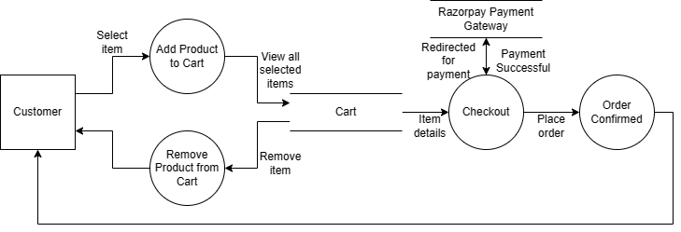

Fig 2.3: Customer Data Flow Diagram

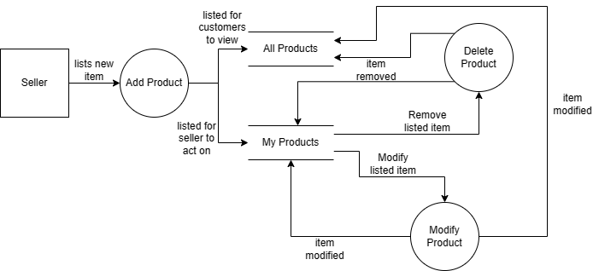

Fig 2.4: Seller Data Flow Diagram

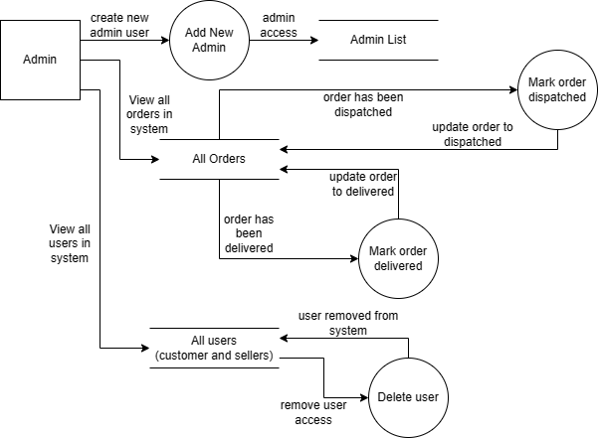

Fig 2.5: Admin Data Flow Diagram

# Technologies Used

* Frontend Technologies: -
* React.js for frontend application (requires Node installation).
* React Router Dom for routing in multipage React application.
* HTML / CSS / JavaScript for UI elements and logic.
* Bootstrap for making the application responsive.
* Font Awesome for icons.
* Razorpay Library for online payment integration.
* Visual Studio Code for development and management of frontend application.
* Backend Technologies: -
* Spring Boot for application layer models, repositories, services and controllers (requires Java JDK and Maven installation).
* Spring Starter Web for RESTful applications using Spring MVC.
* JPARepository for managing data within Spring Boot.
* MySQL Connector to connect and perform CRUD operations on MySQL database.
* MessageDigest Library for password encryption.
* Razorpay Library for online payment integration.
* OpenAPI for API and database schema documentation.
* IntelliJ IDE for development and management of backend application
* Database: -
* MySQL DBMS for storing data and database management.

# Front-end Development

* The frontend has been built using React.js which is an open-source JavaScript framework and library developed by Facebook.
* Rather than dealing with the whole user interface as a single unit, React enables us to separate these complex UIs into individual reusable components that form the building blocks of the whole UI.
* React’s primary role in our application is to handle the view layer of the application by providing the best and most efficient rendering execution.
* React.js framework combines the speed and efficiency of JavaScript with a more efficient method of manipulating the DOM (Document Object Model) to render web pages faster and create a highly dynamic and responsive web application.
* Alongside React, Bootstrap and Font Awesome libraries were also utilised to make the web pages responsive and more creative for all users. Razorpay library was also used to integrate online payments.
* At the frontend the UI displayed to the user differs slightly based on their role: customer, seller and admin. Refer below flowchart to understand each role’s flow through the frontend application.

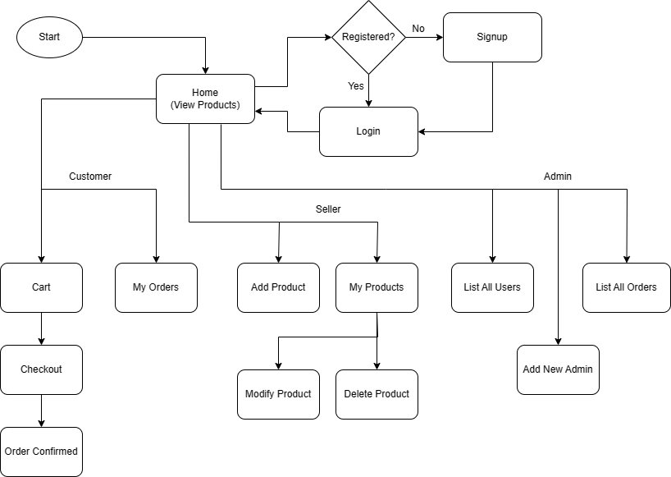

Fig 4.1: Flowchart

* Screenshots: -

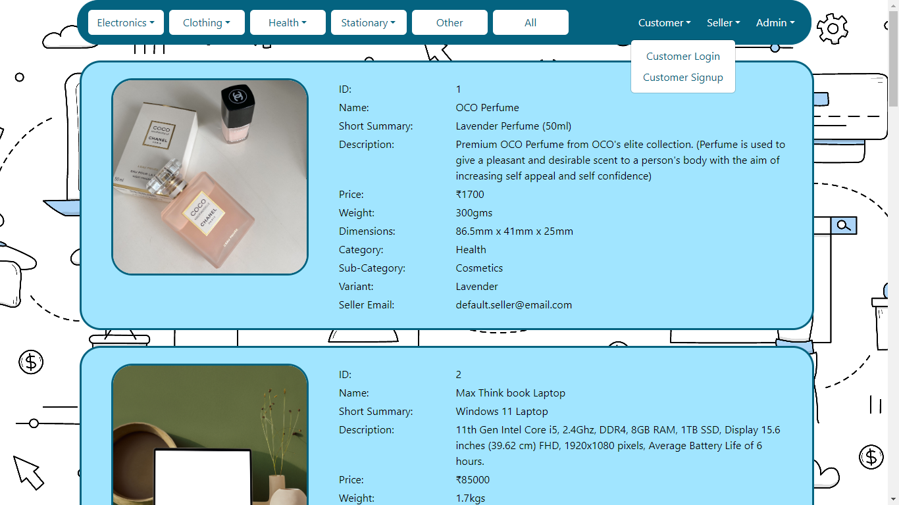

Fig 4.2: Home page for unregistered users

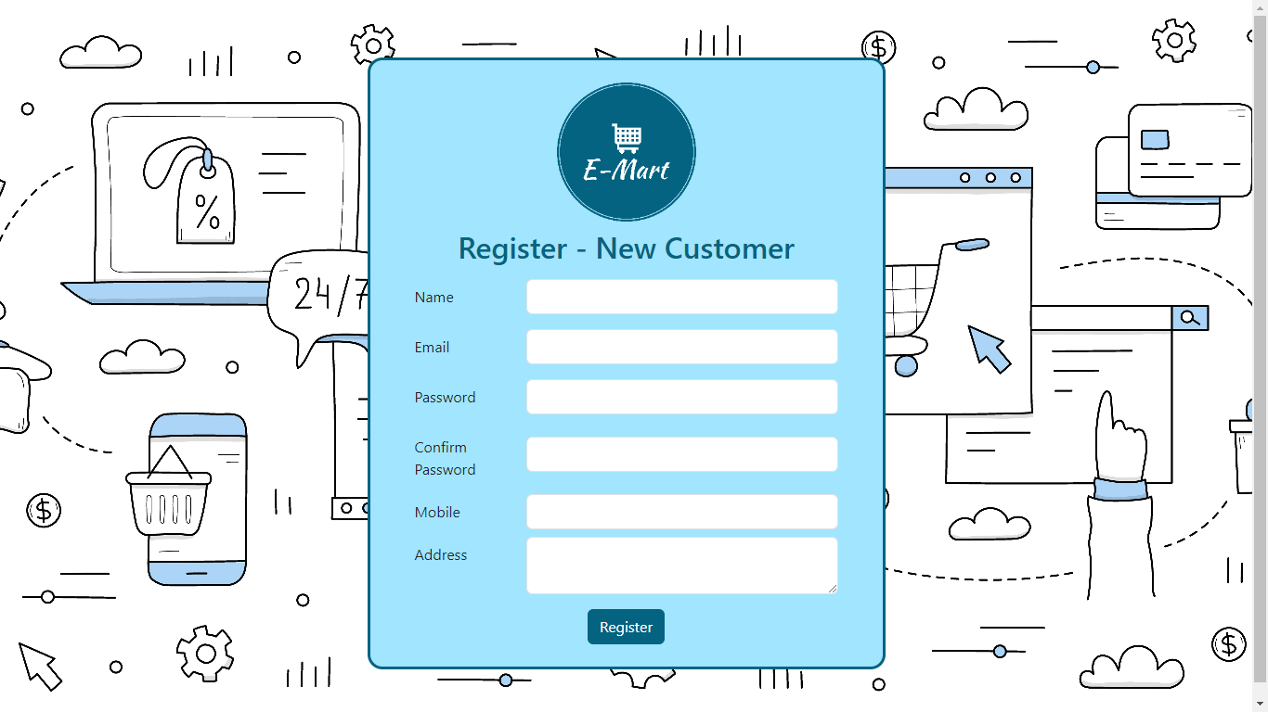

Fig 4.3: Sign up page for customers

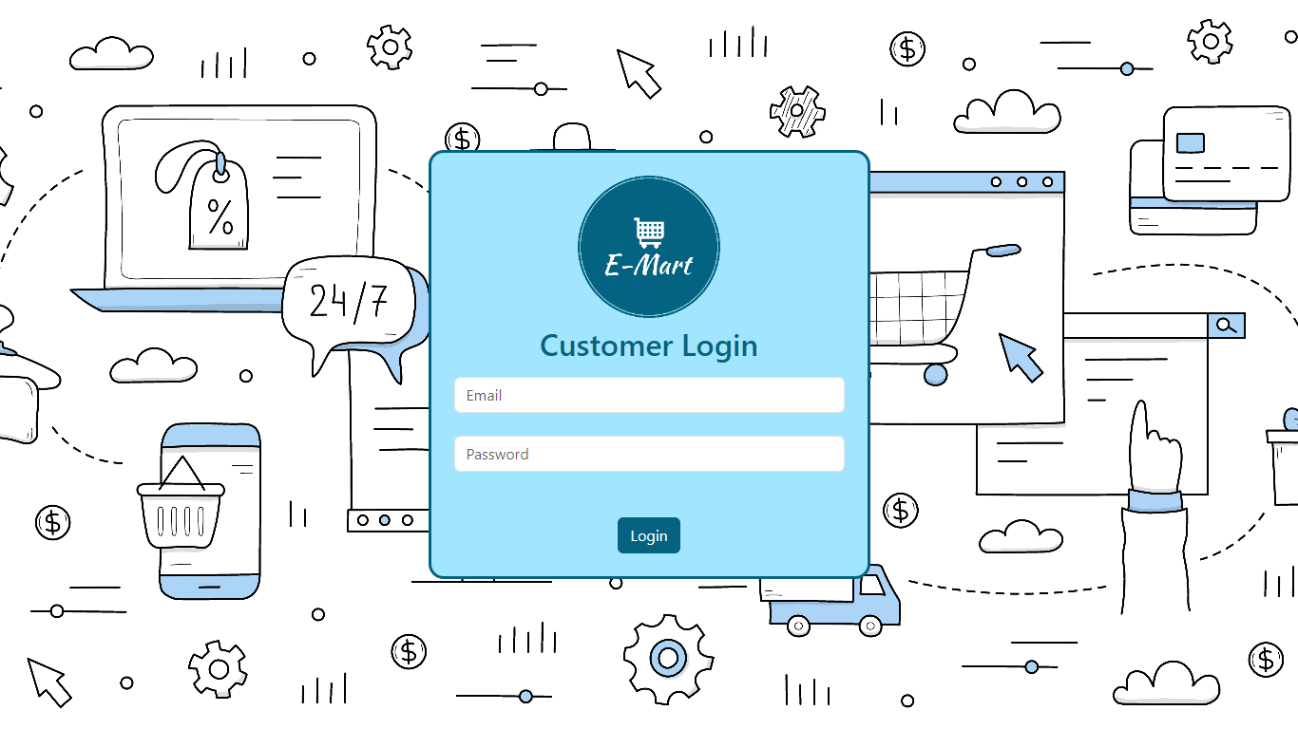

Fig 4.4: Login page for customers

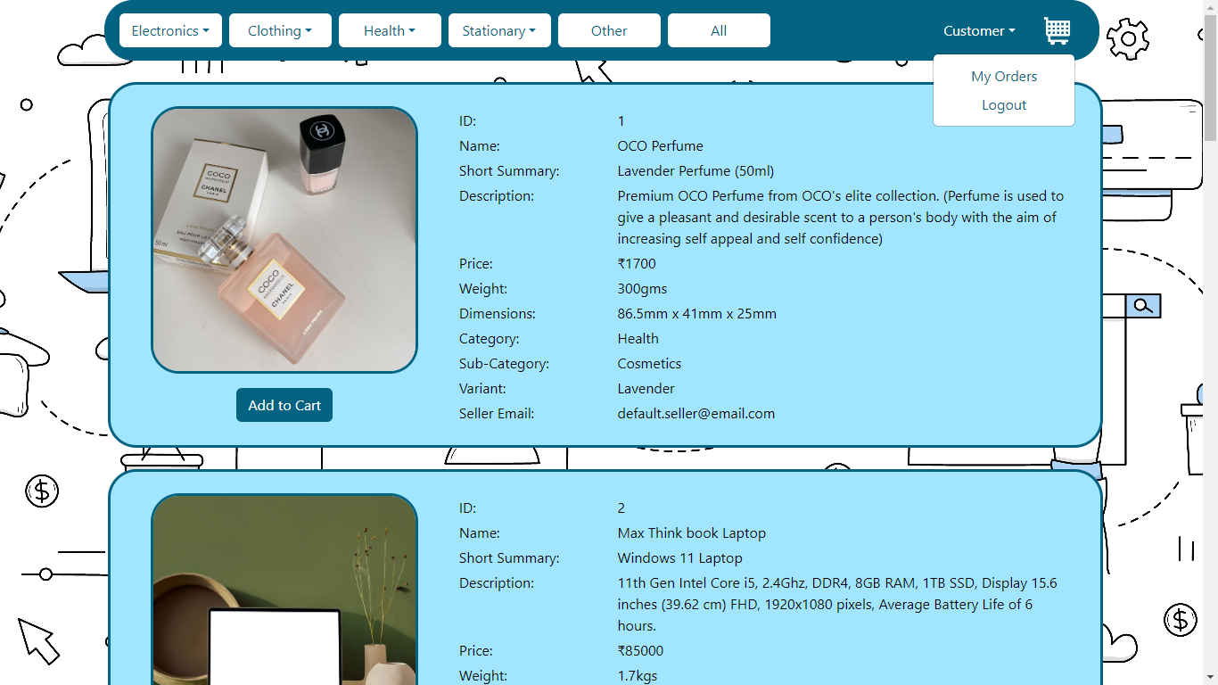

Fig 4.5: Home page for customers after logging in

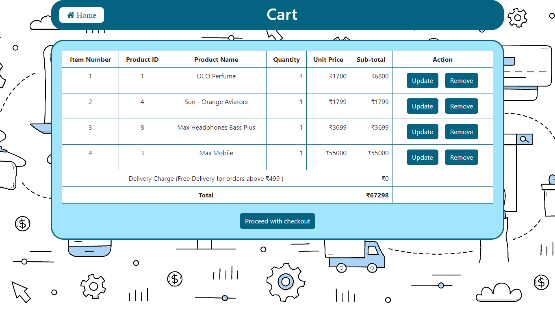

Fig 4.6: Cart page for logged in customers to view items in their cart. Also, allows them to update quantity or remove items from cart.

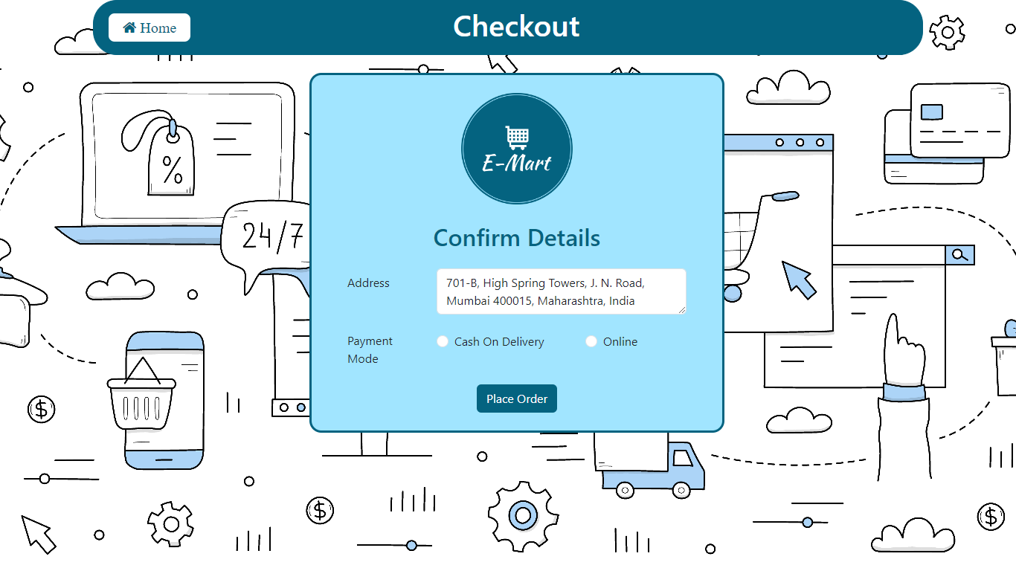

Fig 4.7: Checkout page for customers where address is auto populated from customer’s saved address at the time of signup.

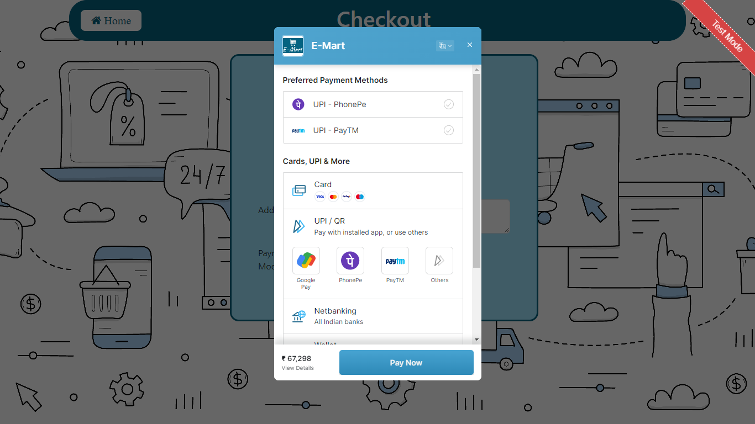

Fig 4.8: Razorpay payment gateway for customers to make online payments

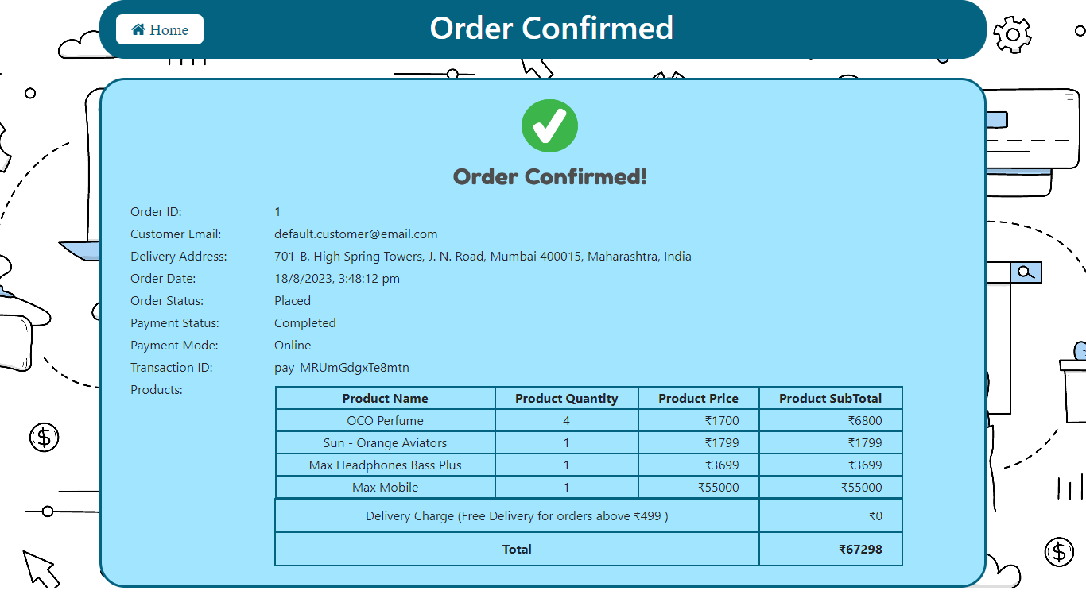

Fig 4.9: Order confirmed page for customers

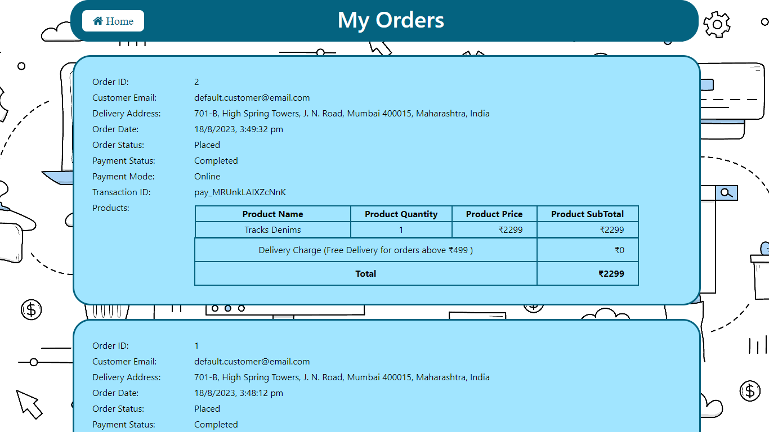

Fig 4.10: My orders page for customers

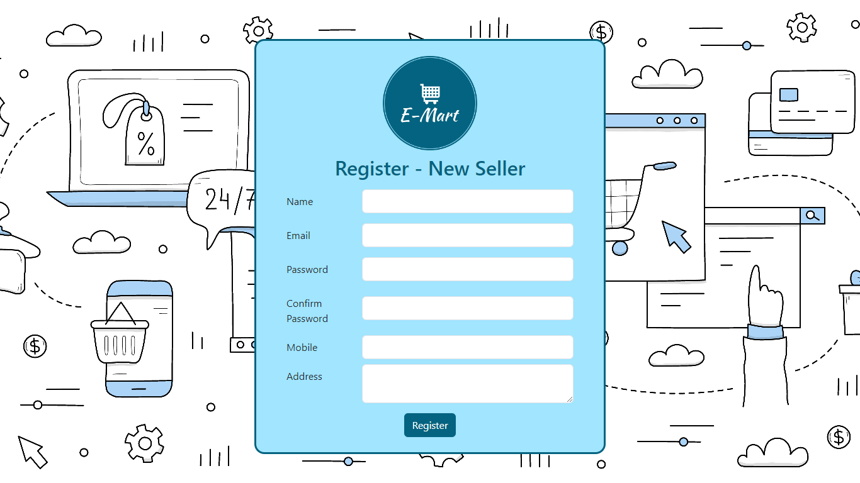

Fig 4.11: Signup page for sellers

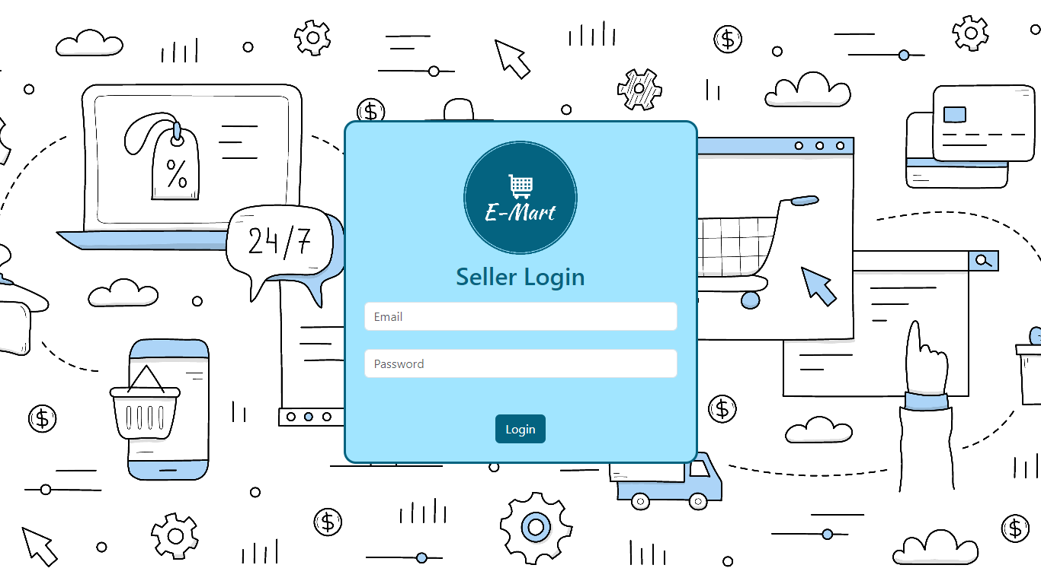

Fig 4.12: Login page for sellers

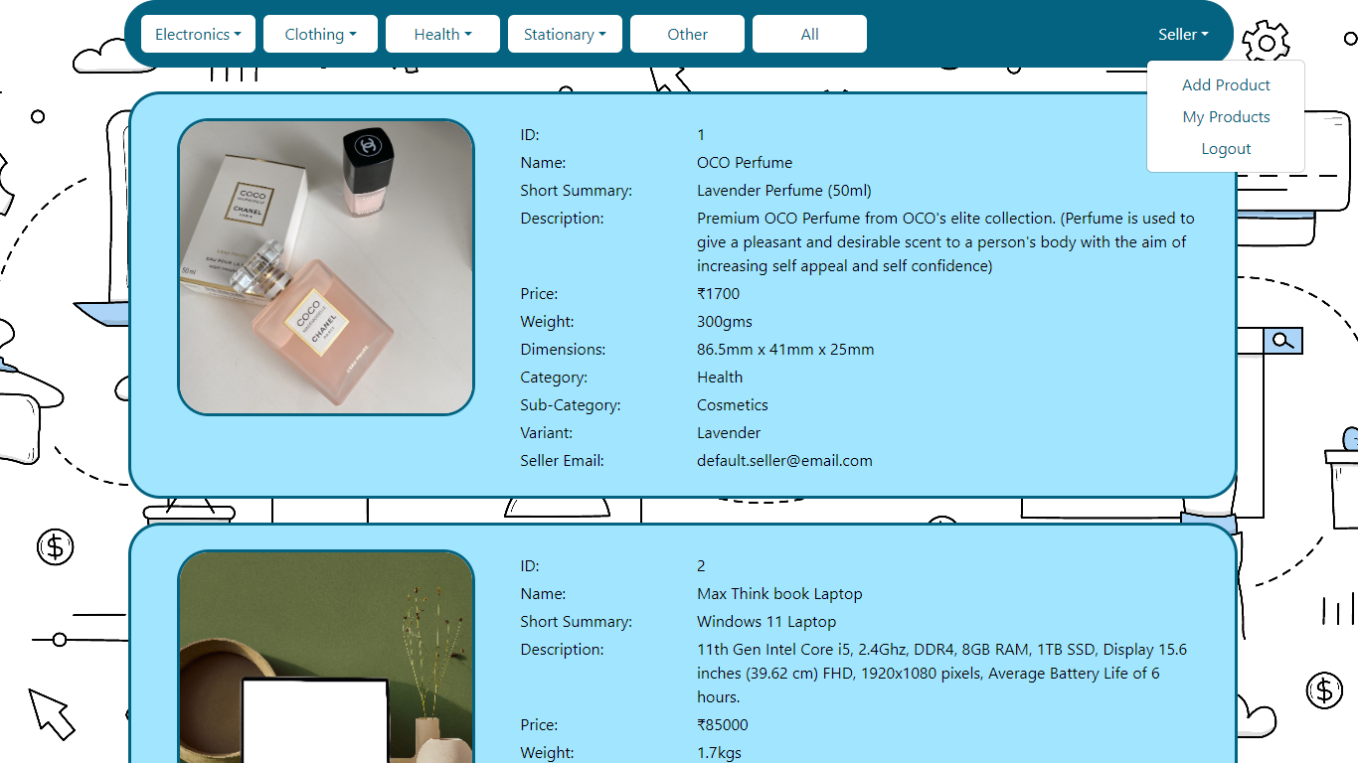

Fig 4.13: Home page for sellers after logging in

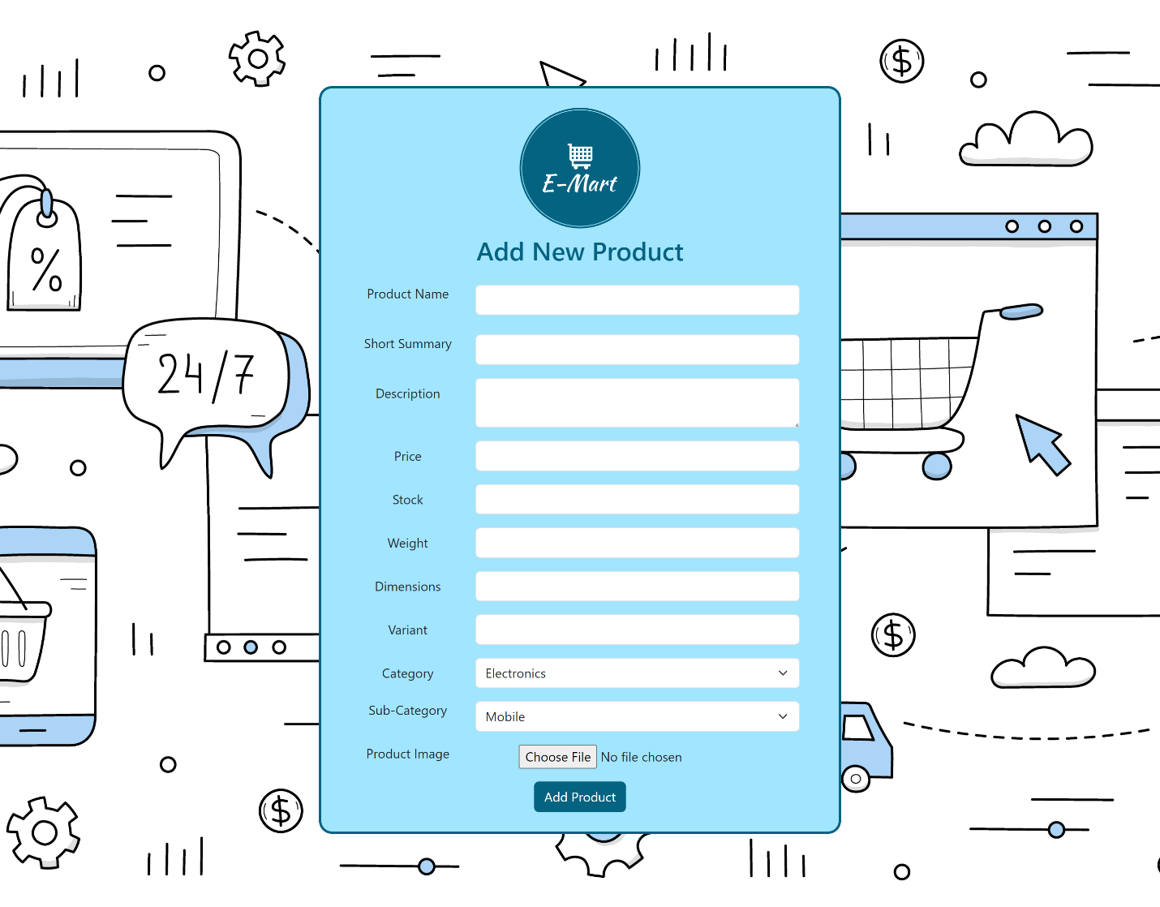

Fig 4.14: Add Product page for sellers to add products

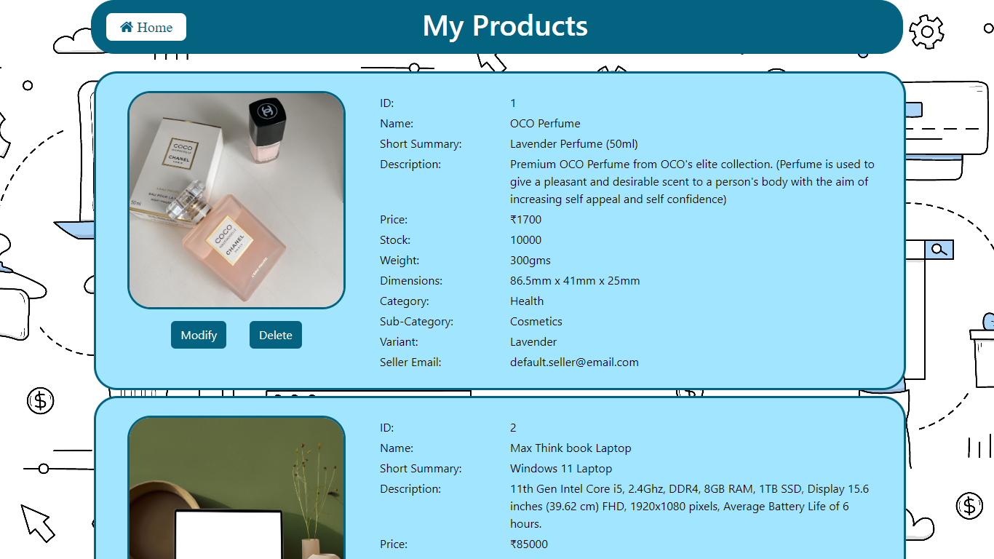

Fig 4.15: My Products page for sellers

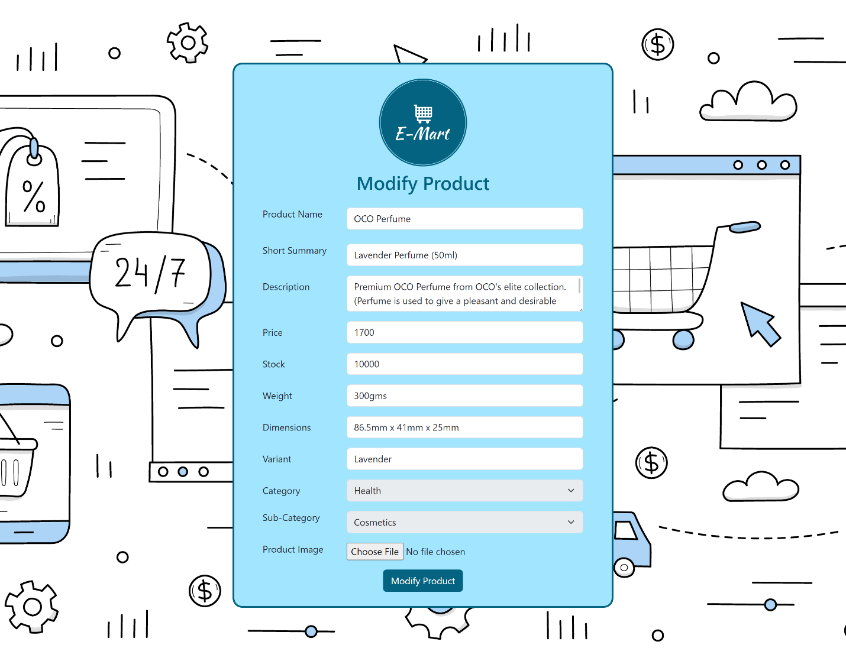

Fig 4.16: Modify Products page auto populates all existing details for seller and allows sellers to modify their product.

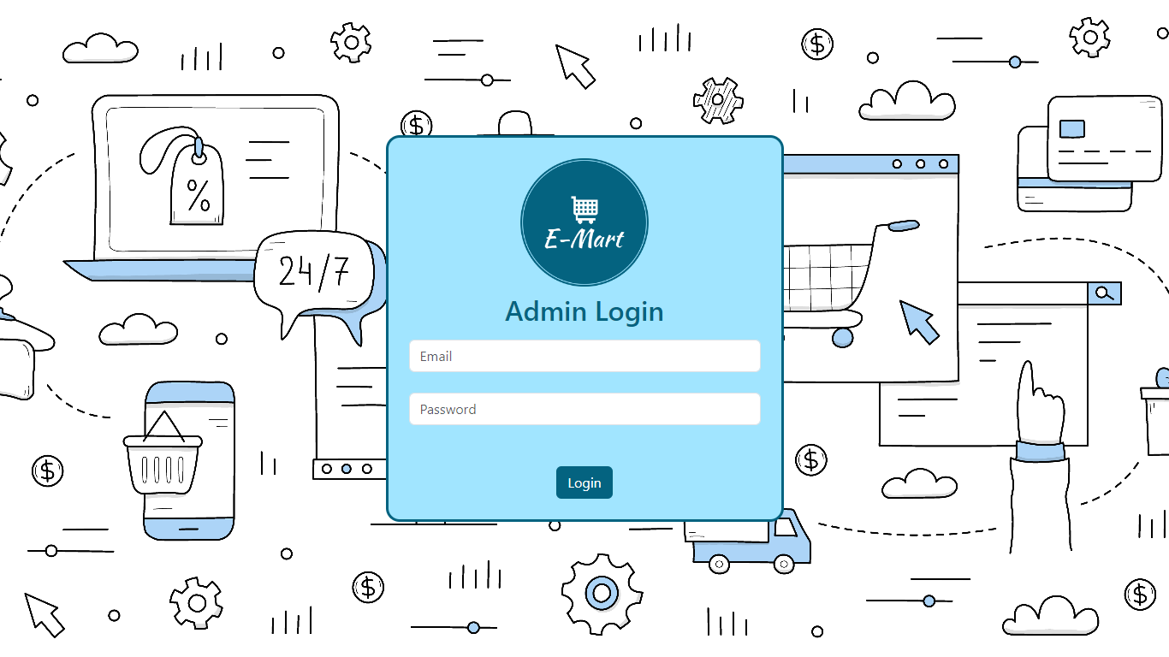

Fig 4.17: Login page for admins

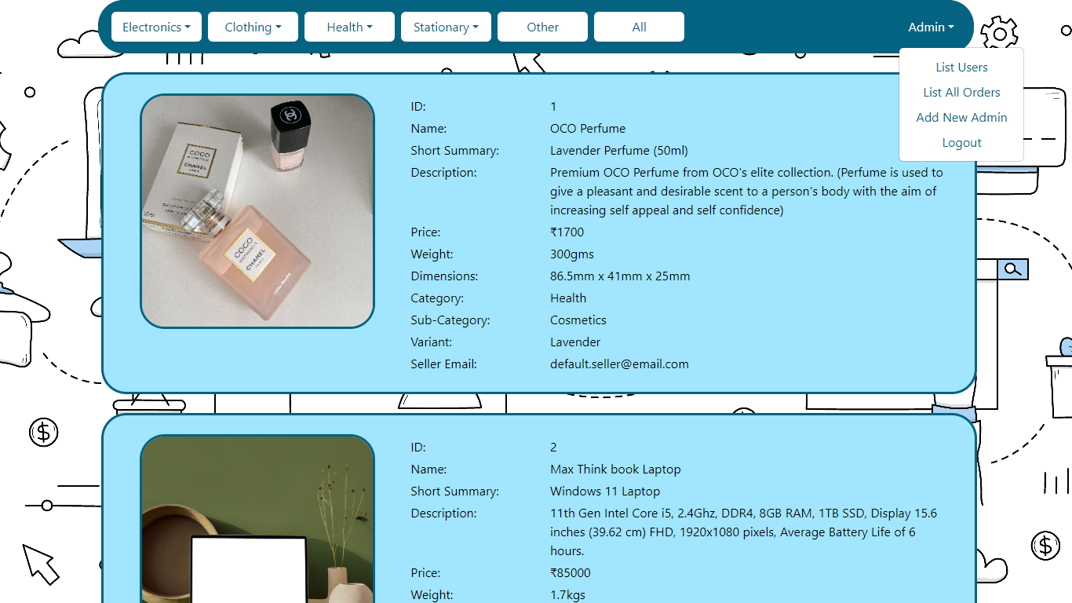

Fig 4.18: Home page for admins after logging in

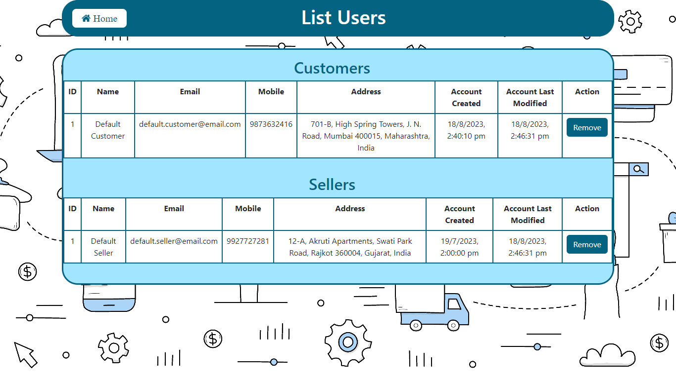

Fig 4.19: List Users page for admins to view all the users (customers and sellers) currently registered in the system. Admins can also remove users from the system.

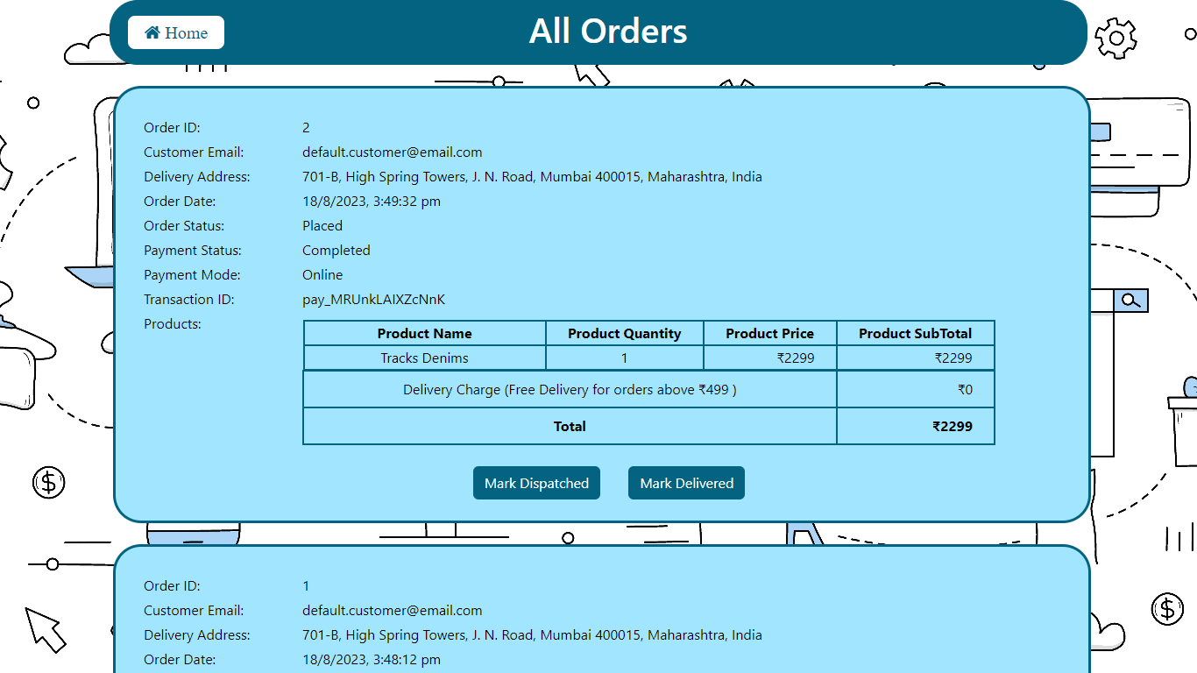

Fig 4.20: All Orders page for admins to view all orders placed in the system. Admins can also mark orders as dispatched and delivered from this page.

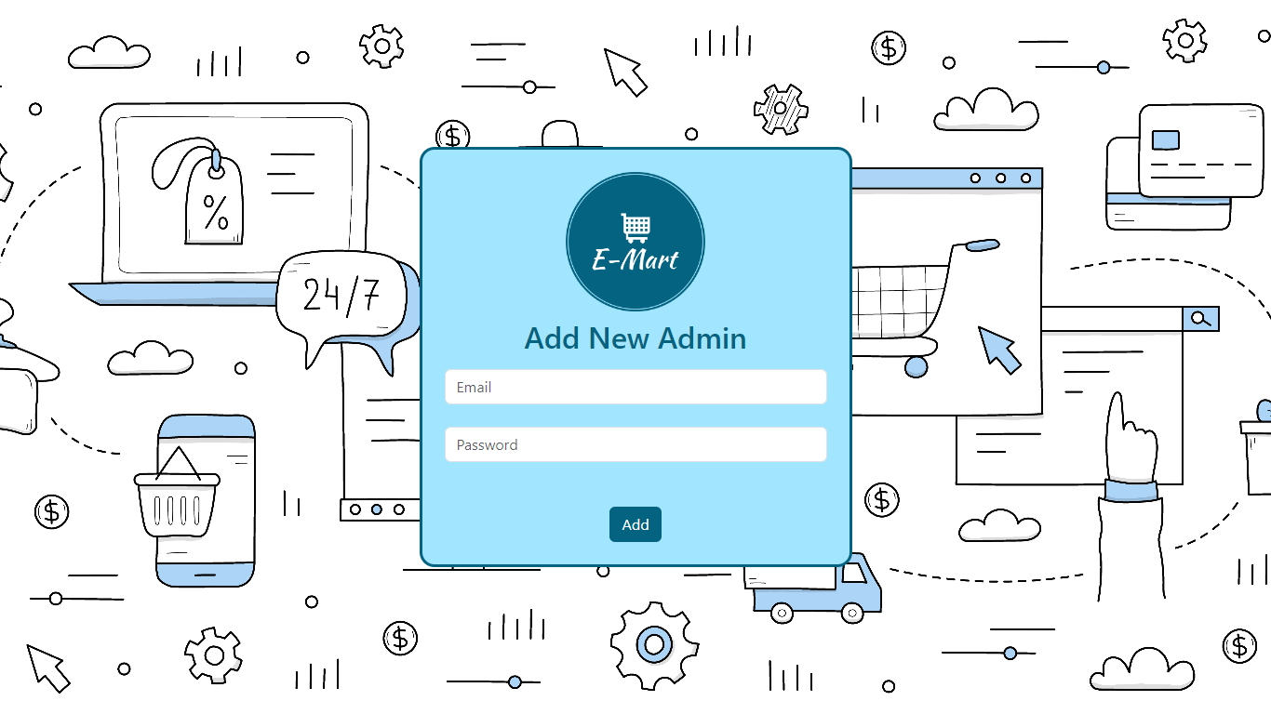

Fig 4.21 Add New Admin page for admin users to provide admin access to a new admin user

# Back-end Development

* The backend application developed is based on the microservices architecture where the application is developed as a collection of services. Microservices architecture provides the framework to develop, deploy and maintain services independently.
* Spring Boot was used to develop the backend application utilizing libraries and frameworks like JPA Repository, Spring Web, Swagger UI and Razorpay API. Spring Boot makes it easy to create stand alone production grade Spring based applications that run on their own without relying on external servers by embedding a web server like Tomcat into your app during initialization.
* Spring Boot is built on top of the conventional Spring framework and is widely used to develop REST APIs.
* In the backend application each entity has its own model, repository, service, and controller to handle their respective operations. Each entity has independent endpoints for API calls however, they are related to each other by defining relationships between them in their respective models.
* The frontend makes API calls to the backend using the API endpoints defined in the controller of each entity. The controller calls methods from the service layer. The service layer in turn utilizes methods defined in the repository to perform CRUD (Create, Read, Update and Delete) operations on the database. The model defines the database schema for entities.
* ER Diagram describing relationships between Entities is displayed below

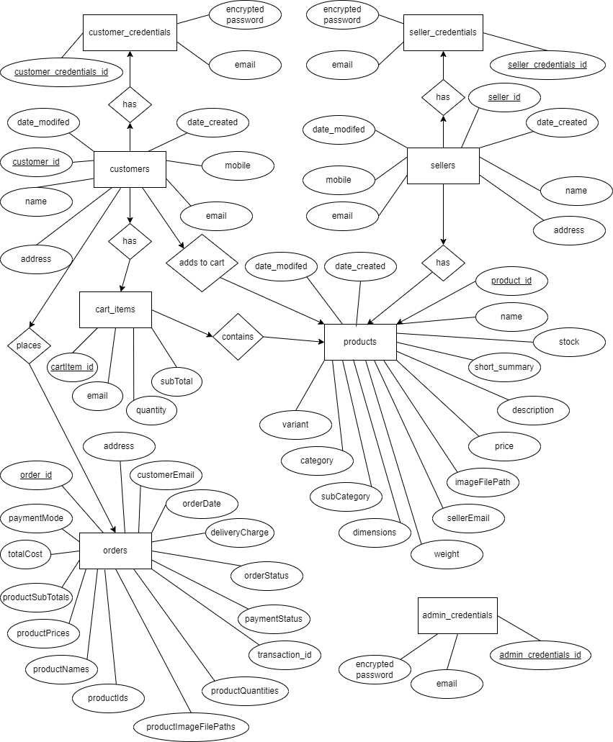

Fig 5.1: Entity-Relationship Diagram

# Database Design

* MySQL database is used in the project to store and manage the data. It is an open-source relational database management system. A relational database organises data in the form of data tables and the data in these tables can be related to each other.
* MySQL was an ideal choice as it is easily scalable, provides cross platform support, multiple storage engines, high performance and efficiency, data security and maintains data integrity.
* Database Schemas: -

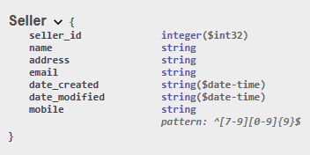

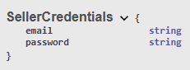

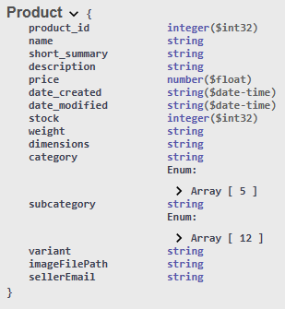

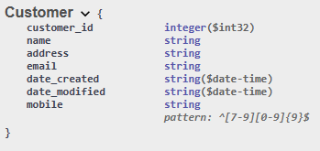

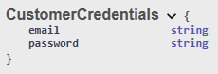

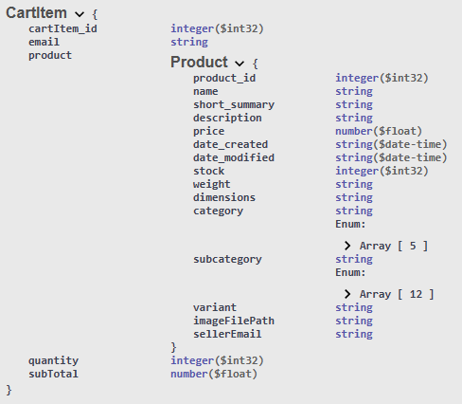

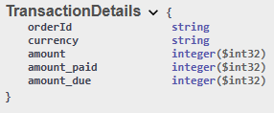

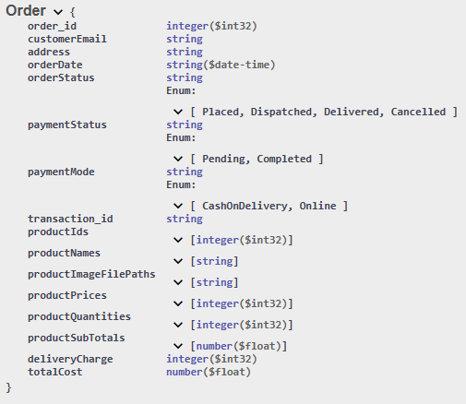

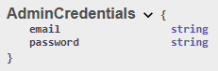

# Authentication and Security

* Customers and Sellers can sign up to use the application by entering details like name, email, password, mobile number and address. All these details are stored securely in a MySQL database. The password is encrypted with SHA-256 algorithm using the MessageDigest library in Java before being stored separately in a different table from all the other data for added security.
* When a customer or seller tries to login, they need to enter their email and password. At the application layer, the entered password is encrypted and compared with the secure hash stored in the database table at the time of signup. If they match, a token is returned and the user is successfully logged in.
* Future plans to implement Okta for SSO to make authentication even more secure are in place.
* Several measures have also been taken to protect user data. The application only collects vital data and no unnecessary data is collected from users. The access to this data is also limited to the user after logging in securely and to application administrators.
* Application administrators can only view user data like name, email, mobile number and address. Passwords are never brought to the frontend and are securely stored in an encrypted format in the database only.

# Project Management

* Project Management is important because it helps provide the team with a clear vision of the goals and objectives, increases productivity, imporves project transparency and helps your project stay within the scope of requirements.
* Agile methodology was adopted for project management. In software development, agile practices include requirement discovery and solutions improvement through the collaborative effort of self-organizing and cross-functional teams.
* Agile is an iterative, incremental and evolutionary model where development is done in short sprints or iteratives in an incremental fashion with continuous evolution and learning from previous completed sprints.
* Each sprint was defined at 7 days and the project was divided into smaller units/user stories and taken up in multiple sprints. Each user story was developed and unit tests were performed within that sprint. A Kanban board was created to track the tasks/user stories that were pending, in-progress and completed. At the end of the final sprint, few days were allocated for SIT (System Integration Testing) where the entire system was tested as a whole.
* Gantt Chart for Project: -

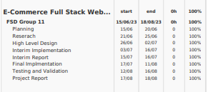

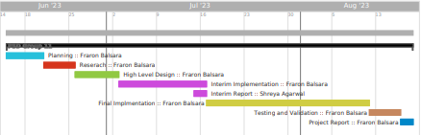

# Results and Evaluation

* The project was successfully completed with the allotted timeframe. All goals and objectives were met.
* Admins can view all products in the system, they can view all the user (both customers and sellers that have signed up in the system) and all orders placed by customers. They can additionally delete users from the system and mark orders dispatched and delivered.
* Sellers after logging in/signing up can view all products, add their own products and also modify or delete products they have added from the ‘My Products’ page.
* Customers can view all the products in the system and add them to their cart after logging in/signing up. Once added to the cart they can manage their cart or proceed with checkout and pay via online Razorpay integration or cash on delivery option. Once checkout is completed the order is placed and the customer will receive their products shortly. Customers are also able to view their past order history through the   
  ‘My Orders’ page.
* Unregistered users can view all the products in the system but cannot perform any actions.
* E-Mart Web Application was designed with an intuitive UI at the frontend, Microservices architecture at the backend and a MySQL database to enhance user experience and ensure high performance and efficiency on all systems. The web application can be accessed from any device like computers, laptops, mobiles, tablets, etc. as it is responsive in nature.

# 10. Conclusion

* An E-Commerce full stack web application called E-Mart was created/developed where sellers can list their products and customers can view and buy these products.
* The main objective of the application was to help local businesses and vendors take their business online and reach customers across geographies. It was also to provide a stable and safe platform for customers to make purchases from these local businesses and avail good quality products directly from the sellers at reasonable prices.
* All of the goals and objectives highlighted were achieved. Sellers can signup and login to add new products, view their products and modify or delete the products they have listed.
* These products are then visible to all users. Registered customers can login and add these products to their cart, manage their cart and buy these products by checking out and making an online payment through Razorpay payment gateway or choosing the cash on delivery option. They can also view all the orders they have placed in the system.
* Admin users are provided with elevated access to help them monitor and handle the orders that are placed as well as the users in the system. Admins can remove users from the system and mark orders as dispatched and delivered.
* E-Mart Web application is a cross platform, user friendly and responsive web application that can be accessed by anyone on any device with an internet connection thus enabling sellers to easily signup and move their businesses online and allowing customers to shop form anywhere and anytime at their convenience.